Practical :-12

Prepare a Servlet to demonstrate Session tracking using HTTP Session with output. How Many time user has visited the site with time.

Program:-

Sessionpro.java

import java.io.IOException;

import java.io.PrintWriter;

import javax.servlet.ServletException;

import javax.servlet.http.HttpServlet;

import javax.servlet.http.HttpServletRequest;

import javax.servlet.http.HttpServletResponse;

import java.io.\*;

import java.sql.\*;

import java.net.\*;

import javax.servlet.http.\*;

public class SessionProg extends HttpServlet {

protected void processRequest(HttpServletRequest request, HttpServletResponse response)

throws ServletException, IOException

{

response.setContentType("text/html;charset=UTF-8");

try (PrintWriter out = response.getWriter()) {

/\* TODO output your page here. You may use following sample code. \*/

String Username = request.getParameter("username");

String Password = request.getParameter("password");

HttpSession session;

String UsernameKey = "userID";

Integer visitCount = 1000;

String visitCountKey = "visitCount";

Date creationTime,lastAccessedTime;

out.println("<!DOCTYPE html>");

out.println("<html>");

out.println("<head>");

out.println("<title>Servlet SessionProg</title>");

out.println("</head>");

out.println("<body>");

try

{

Class.forName("sun.jdbc.odbc.JdbcOdbcDriver");

Connection con = DriverManager.getConnection("jdbc:odbc:Login");

Statement st = con.createStatement();

ResultSet rs = st.executeQuery("select password from login where uname='"+Username+"'");

if (rs.next())

{

String dbmsPwd = rs.getString(1);

if (dbmsPwd.equals(Password))

{

out.println("<h4>Successfully logged in </h4>");

session = request.getSession(true);

creationTime = new Date(session.getCreationTime());

lastAccessedTime = new Date(session.getLastAccessedTime());

if (session.isNew())

{

session.setAttribute(UsernameKey,Username);

}

else

{

visitCount = (Integer)session.getAttribute(visitCountKey);

visitCount = visitCount + 1;

//Username = (String)session.getAttribute(UsernameKey);

}

session.setAttribute(visitCountKey, visitCount);

out.println("<h4>Hi User, you visit this page " + visitCount.toString() + " times.. </h4>");

}

else

{

out.println("<h4>Failure</h4>");

}

}

else

{

out.println("<h4>Invalid Username or Password</h4>");

}

}

catch (Exception e)

{

out.println("<h4>" + e.getMessage()+ "</h4>");

}

out.println("</body>");

out.println("</html>");

}

}

Index.html:-

<html>

<head>

<title>TODO supply a title</title>

<meta charset="UTF-8">

<meta name="viewport" content="width=device-width, initial-scale=1.0">

</head>

<body>

<div>

<form action="SessionProg" method="POST" name="UserLogin">

<table>

<tr>

<td>Username: </td>

<td><input type="text" name="username"/></td>

</tr>

<tr>

<td>Password: </td>

<td><input type="password" name="password"/></td>

<tr>

</tr>

<td><input type="submit" value="Login"/></td>

<td><input type="reset" value="Reset"/></td>

</tr>

</table>

</form>

</div>

</body>

</html>

Output:-

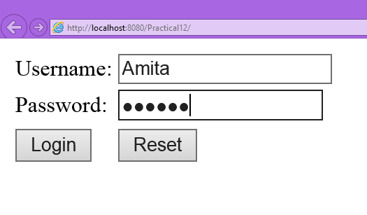

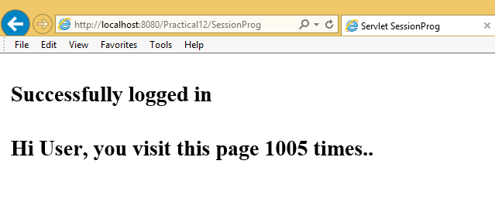

Top of Form

Bottom of Form

Top of Form

Bottom of Form

Top of Form

Bottom of Form